2017 FBINAA Maryland/Delaware Chapter Event
Annual Crab Feast

Fisherman’s Crab Deck
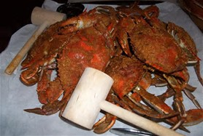
3116 Main Street
Grasonville, MD 21638
Friday, October 6, 2017
Beginning At 11:00 a.m.
Name |  |  |  |  |  |  |  | Session #
Phone # | - - |  |  | Cell # | - - | E-mail
Mailing Address |  |  |  |  |  |  |  | Retired | Yes No
City/State/Zip
Agency
Event Cost: |  | $60.00/Person Includes All You Can Eat & Drink
Additional Guest(s):
 |  |  |  |  |  |  |  | Total Cost:$
Deadline To Purchase Tickets Is September 29, 2017

Directions to Fisherman’s Crab Deck are found at www.fishermansinn.com

Credit Card payment accepted. Payment by check preferred.
Card Type: | MC VISA AMEX
Card #: | CVC: | EXP:
Make checks payable to: FBINAA Maryland Delaware Chapter

Return form and payment to:
Daniel Galbraith
Chapter Secretary/Treasurer
2846 Bynum Overlook Drive
Abingdon, Maryland 21009
Telephone: 410-808-8896 or E-mail: galbraithd@harfordsheriff.org

