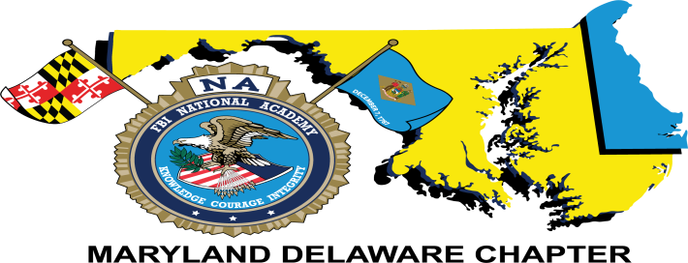
2017 FBINAA Maryland/Delaware Chapter Event
Navy Tailgating
Navy-Marine Corps Memorial Stadium
Saturday, September 9, 2017
Navy Midshipmen vs Tulane Green Wave
Tailgating begins at 12:00 p.m. with the game beginning at 3:30 p.m.
Game tickets will be distributed at the tailgate function.

Name |  |  |  |  |  |  |  | Session #
Phone # |  |  |  | Cell # |  | E-mail
Mailing Address |  |  |  |  |  |  |  | Retired | Yes ___ No ___
City/State/Zip
Agency
Event Cost: |  | $45.00/person includes tailgating and game ticket
Additional Guest(s):
 |  |  |  |  |  |  |  | Total Cost:$
Deadline To Purchase Tickets Is September 1, 2017

FREE parking is available at the Annapolis Police Department located at 199 Taylor Avenue – less than ¼ mile from the tailgate venue. More Information will be sent out later with our NEW tailgate location.

Credit Card payment accepted. Payment by check preferred.
Card Type: | MC __ VISA __ AMEX __
Card #: | CVC: | EXP:
Make checks payable to: FBINAA Maryland Delaware Chapter
Return form and payment to:
Daniel Galbraith
Chapter Secretary/Treasurer
2846 Bynum Overlook Drive
Abingdon, Maryland 21009
Telephone: 410-808-8896 or E-mail: galbraithd@harfordsheriff.org

