2018 FBINAA Maryland/Delaware Chapter Event
Baltimore Orioles vs Philadelphia Phillies
Wednesday May 16, 2018
Lunch at 11:00 a.m. with the first pitch at 12:35 p.m.
Game tickets will be distributed at the lunch.

The lunch is in the Camden Yard Warehouse, Camden Club.
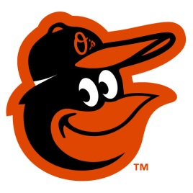
Menu:
Grilled Sirloin Hamburgers
ESSKAY All-Beef Hot Dogs with all the Trimmings
Grilled Italian Sausage
Boog’s Baked Beans
Seasonal Vegetables
Kosher Pickles
Seasonal Fruit
Chesapeake Style Coleslaw
House Made Kettle Chips
Assorted Cookies

All Menu Selections Include Domestic Beers and Assorted Coca-Cola Products

http://baltimore.orioles.mlb.com/bal/ballpark/transportation/index.jsp

2018 FBINAA Maryland/Delaware Chapter Event
Annual “Take Me Out To The Ballgame”
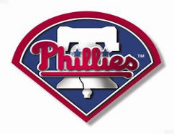
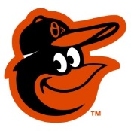

May 16, 2018

Warehouse lunch/social hour at 11:00 a.m. with game to follow at 12:35 p.m.

Name |  |  |  |  |  |  |  | Session #
Phone # |  |  |  | Cell # |  | e-mail
Mailing Address
City/State/Zip
Agency
Event Cost: |  | $45.00/person includes game ticket, lunch & Coca Cola products as well as a selection of domestic beers.
Additional Guest(s):
Check method of payment: Check ____ Credit Card or Debit Card ____ |  |  |  |  |  |  |  | Total Cost:$

Card Type: | MC ___ VISA __ AMEX __
Card #: | CVC: | EXP:
Make checks payable to: FBINAA Maryland Delaware Chapter
Return form and payment to:

MDDE Chapter Secretary/Treasurer
Dan Galbraith
2846 Bynum Overlook Drive
Abingdon, Maryland 21009

galbraithd@harfordsheriff.org
410-808-8896

