2018 FBINAA Maryland/Delaware Chapter Re-trainer
Holiday Inn Oceanfront
6600 Coastal Highway
Ocean City, Maryland 21842

Wednesday, April 11 – Friday, April 13, 2018
Join us for 3 days of training and networking with FBINAA members!
Wednesday, April 11
11:30am – 4:00pm: Safariland Body Armor Demo
2:30pm - 5:30pm: Hotel check in & conference registration
6:00pm - 9:00pm: Presidents Welcome Reception
9:00pm - 11:00pm: Information Sharing
Bonfire on the Beach (Weather permitting)

Thursday, April 12

7:30am - 8:00am: Registration
8:00am - 5:00pm: Workshops/ Vote on Bylaw Change
6:00pm - 7:00pm: Vendor social hour
7:00pm - 9:00pm: Conference Banquet
9:00pm – 11:00pm: Information Sharing

Friday, April 13

8:30am - 4:30pm: Workshops
5:00pm – 8:00pm: Dinner on your own
8:00pm - 11:00pm: Information Sharing

Conference Registration $225.00

Hotel Accommodations: $69.00/night*

Hotel reservations can be made by calling 410-524-1600 use the booking code National Academy Training
*Cut-off to guarantee room rate is March 21, 2018

WORKSHOPS

Safariland Body Armor – Demo
Ocean City PD Range
Bus Transportation Provided from Hotel

Eric Frein Case Study
PA State Police, Major Doug Burig

Leadership
Harford County Sheriff’s Office, Colonel Steven Bodway

Surviving Traumatic Injuries
Retired Baltimore PD, Eugene “Gene” Cassidy

How a Pot Hole Saved an Officers Life (PTSD)
Covington PD, LA – Chief Tim Lentz and Former Officer Blake Adair

Officer Involved Shooting Case Study
Queen’s Anne’s County Sheriff’s Office, Deputy Scott Hogan

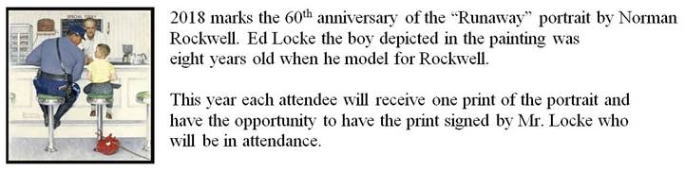

2018 FBINAA Maryland/Delaware Re-trainer Registration Form

EVENT COST: $225.00
Hotel accommodations are separate and made directly with the Holiday Inn Oceanfront –
410-524-1600
Name |  |  |  |  |  |  | Session #
Phone # |  |  | Cell # |  | e-mail
Mailing Address |  |  |  |  |  |  | Retired | Yes ___ No ___
City/State/Zip
Agency
I plan to attend the Safariland Body Armor Demo on Wednesday afternoon? (circle one) YES NO
I plan to attend the President’s Reception on Wednesday evening? (circle one) YES NO
I plan to attend the Banquet on Thursday evening? (circle one) YES NO

Name |  |  |  |  |  |  | Session #
Phone # |  |  | Cell # |  | e-mail
Mailing Address |  |  |  |  |  |  | Retired | Yes ___ No ___
City/State/Zip
Agency
I plan to attend the Safariland Body Armor Demo on Wednesday afternoon? (circle one) YES NO
I plan to attend the President’s Reception on Wednesday evening? (circle one) YES NO
I plan to attend the Banquet on Thursday evening? (circle one) YES NO

Name |  |  |  |  |  |  | Session #
Phone # |  |  | Cell # |  | e-mail
Mailing Address |  |  |  |  |  |  | Retired | Yes ___ No ___
City/State/Zip
Agency
I plan to attend the Safariland Body Armor Demo on Wednesday afternoon? (circle one) YES NO
I plan to attend the President’s Reception on Wednesday evening? (circle one) YES NO
I plan to attend the Banquet on Thursday evening? (circle one) YES NO
***Attach additional pages if needed***
“Checks are preferred”
Card Type: | MC __ VISA __ AMEX __
Card #: | CVC: | EXP:
Make checks payable to: FBINAA Maryland Delaware Chapter
Return form and payment to:
Dan Galbraith
MD/DE Chapter Secretary/Treasurer
2846 Bynum Overlook Drive
Abingdon, Maryland 21009
galbraithd@harfordsheriff.org
410-836-5454

