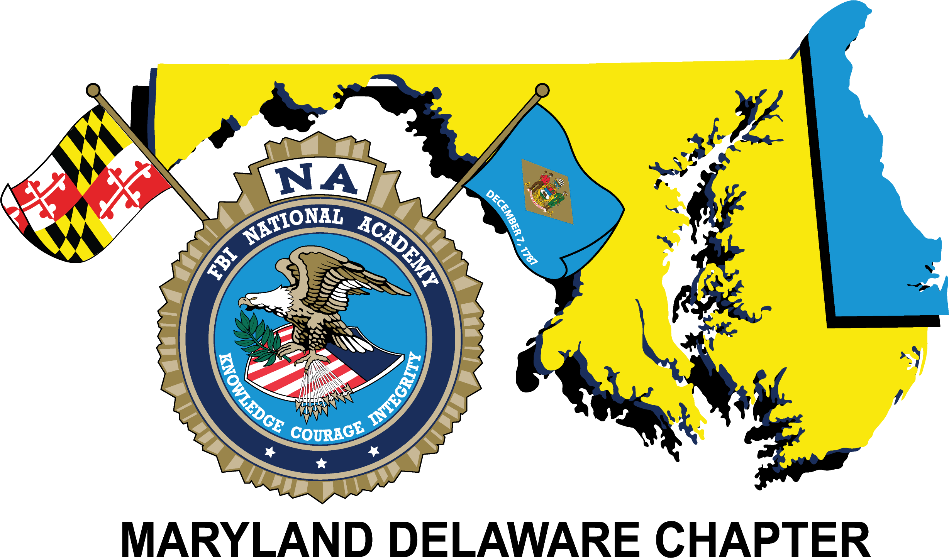

2019 Annual Re-trainer
April 2nd – 4th

Holiday Inn Oceanfront
Ocean City, Maryland

Tuesday – April 2

3:00 p.m. – 6:00 p.m. Attendee Registration/Vendor Set-up Hotel Conf. Center

7:00 p.m. – 9 p.m. President’s Reception (Casual Attire) Hotel Conf. Center
Buffet Food Stations and Refreshments

9:00 p.m. – 11:30 p.m. Chapter Membership Information Sharing Room 225/226
Bonfire Beach

All Training will be held in the Conference Center. Dress will be business casual.

Wednesday – April 3

7:00 a.m. – 8:30 a.m. Buffet Breakfast- Conference Center Lobby

8:30 a.m. – 9:00 a.m. Opening Remarks and Sponsor Message

9:00 a.m. – 10:15 a.m. Rite Aid Warehouse Shooting (Harford County- Colonel Bill Davis)

10:15 a.m. – 10:45 a.m. Break and Vendor Displays

10:45 a.m. – 12:00 p.m. Rite Aid Warehouse Shooting (Harford County- Colonel Bill Davis)

12:00 p.m. – 1:00 p.m. (Lunch) -Conference Center Lobby

1:00 p.m. – 2:00 p.m. Washington Navy Yard Active Shooter Case (FBI Agent Erin Sheridan)

2:00 p.m. – 2:20 p.m. Break and Vendor Displays

2:20 p.m. – 2:30 p.m. Sponsor Messages

2:30 p.m. – 4:30 p.m. Terrorism/ Strait of Hormuz Plot (FBI Assistant Director, Security
Division Jerry Roberts)

5:00 p.m. - 5:25 p.m. Group Photo with “Yellow Bricks” Beach

5:45 p.m. – 6:45 p.m. Vendor Social Hour – Harrison
7:00 p.m. – 9:00 p.m. Dinner Banquet – Orlando/Berlin (Dress: Business Casual)
Speaker and Recognitions

9:00 p.m. – 11:30 p.m. Chapter Membership Information Sharing Room 225/226

Thursday – April 4

All Training will be held in the Conference Center. Dress will be business casual.

7:00 a.m. – 8:30 a.m. Buffet Breakfast- Conference Center Lobby

8:30 a.m. – 10:30 a.m. Platte Canyon Colorado School Shooting (John Michael Keyes)
(AJ DeAndria- Tactical Commander)

10:30 a.m. – 10:45 a.m. Break

10:45 a.m. – 12:45 p.m. Platte Canyon Colorado School Shooting (John Michael Keyes)
(AJ DeAndria- Tactical Commander)

12:45 p.m. – 1:45 p.m. Lunch provided

1:45 p.m. – 2:00 p.m. Sponsor messages

2:00 p.m. – 3:15 p.m. Domestic Terrorism and Homegrown Violent Extremism (FBI Agent Tom O’Connor)

3:15 p.m. – 3:30 p.m. Break and Vendor Displays

3:30 p.m. – 4:15 p.m. Domestic Terrorism and Homegrown Violent Extremism
(FBI Agent Tom O’Connor)

4:30 p.m. Conference Adjourns / Certificates Available

Dinner on your own

7:00 p.m. – 10:00 p.m. Chapter Membership Information Sharing Room 225/226

Thank you to MAGLOCLEN, FBI Baltimore Field Office, and the Ocean City Maryland Police Department for their logistical support.
On behalf of the entire FBINAA Maryland-Delaware Executive Board, thank you for attending this year’s training!
- Laura O’Sullivan, President
- Joe Conger, Vice President
- Danny Meadows, 1st Vice President
- Orlando Lilly, Sergeant at Arms
- Dan Galbraith, Secretary/Treasurer
- Scott Kolb, Immediate Past President
- Steve Shepherd, Training Coordinator – FBI Baltimore

