2019 FBINAA Maryland/Delaware Chapter Event
Annual Golf Tournament
Monday, August 19, 2019

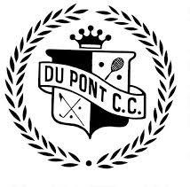
DuPont Country Club
1001 Rockland Road, Wilmington, Delaware 19803 Tournament benefits the Chapter Scholarship Fund,
Maryland/Delaware Special Olympics, and FBI Youth Leadership Program

Registration will begin @ 8:00 a.m. Shotgun Start @ 9:00 a.m.
Prizes / Longest Drive / Closest to the Pin

Lunch, beer, soda, and water are included throughout the day on the course.

COST
$135.00 per golfer

Limited to first 144 PAID Golfers
Entries must be submitted by August 12, 2019

2019 Golf Tournament Registration

Organization Representing: ___ _ __ _ ___ __ _ _

Name | E-mail Address | Telephone Number

Make Checks Payable to: FBINAA Maryland/Delaware Chapter

Return this form with your check to:

Captain Laura O’Sullivan, New Castle County PD
3601 N. DuPont Hwy, New Castle, Delaware, 19720

For additional information regarding this tournament, please feel free to call Laura at 302-373-0702 or email her at Laura.OSullivan@newcastlede.gov

Return paid registration by: August 12, 2019

Please visit our website at www.fbinaamdde.com for more information

