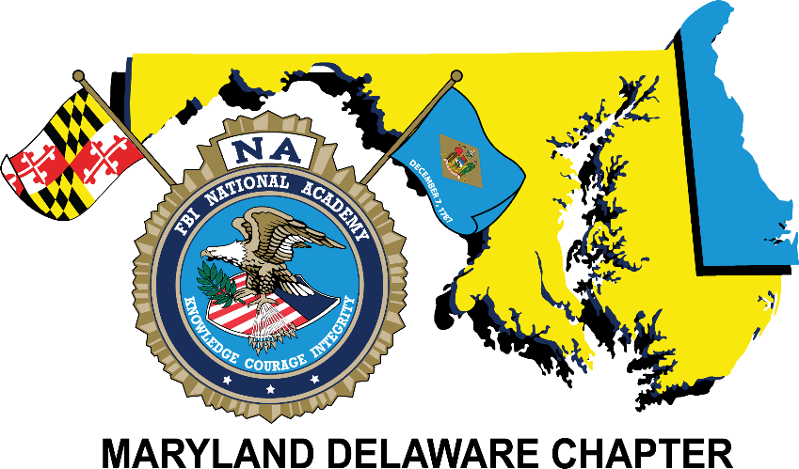
Maryland-Delaware Chapter
2020 Annual
Conference & Re-trainer
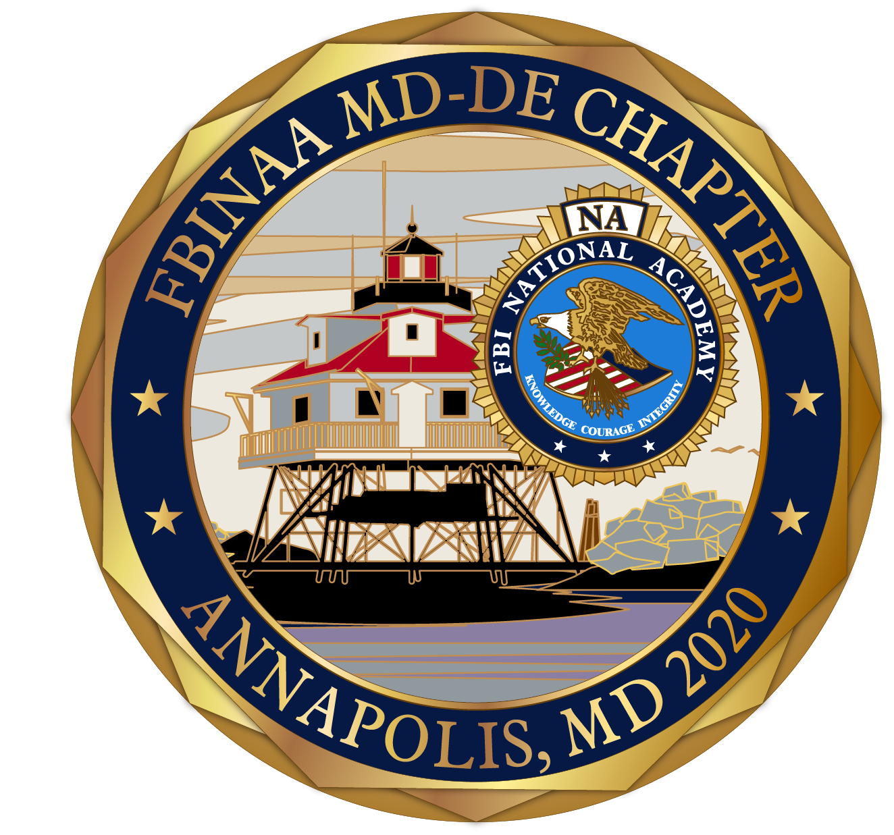
April 7th – 9th

DoubleTree by Hilton
Annapolis, Maryland
Tuesday April 7th
3:00pm – 6:00pm | Guest Registration  Vendor Setup | Ballroom Lobby  Ballroom
7:00pm – 9:00pm | President’s Reception (Casual Attire)  Buffet Food Stations & Refreshments | Harbour Ballroom
9:00pm – 11:30pm | Chapter Membership Information Sharing | Hospitality Suite

Wednesday April 8th
7:00am – 8:30am | Buffet Breakfast | Ballroom Lobby
8:30am – 9:00am | Opening Remarks & Sponsor Message | Ballroom
9:00am – 10:30am | Training Session: (TBD) | Ballroom
10:30am – 10:45am | Break & Vendor Displays | Ballroom
10:45am – 12:15pm | Training Session: (TBD) | Ballroom
12:15pm – 1:15pm | Lunch | Ballroom Lobby
1:15pm – 2:30pm | Training Session: (TBD) | Ballroom
2:30pm – 2:45pm | Break & Vendor Displays | Ballroom
2:45pm – 3:00pm | Sponsor Messages | Ballroom
3:00pm – 4:30pm | Training Session: (TBD) | Ballroom
5:45pm – 6:45pm | Corporate Partner Social Hour | Ballroom Lobby
7:00pm – 9:00pm | Banquet Dinner  Speaker & Recognitions | Ballroom
9:00pm – 11:30pm | Chapter Membership Information Sharing | Hospitality Suite

Thursday April 9th
7:00am – 8:30am | Buffet Breakfast | Ballroom Lobby
8:30am – 9:30am | Training Session: (TBD) | Ballroom
9:30am – 9:45am | Break & Vendor Displays | Ballroom
9:45am – 11:00am | Training Session: (TBD) | Ballroom
11:00am – 11:15am | Break & Vendor Displays | Ballroom
11:15am – 12:15pm | Training Session: (TBD) | Ballroom
12:15pm – 1:15pm | Lunch | Ballroom Lobby
1:15pm – 2:30pm | Training Session: (TBD) | Ballroom
2:30pm – 2:45pm | Sponsor Messages | Ballroom
2:45pm – 4:15pm | Training Session: (TBD) | Ballroom
4:15pm – 4:30pm | Conference Adjourns  Certificates Available | Ballroom
4:30pm – 7:00pm | DINNER ON YOUR OWN
7:00pm – 10:00pm | Chapter Membership Information Sharing | Hospitality Suite

Friday April 10th
11:00am | Hotel Checkout  Guest Departure | Lobby

