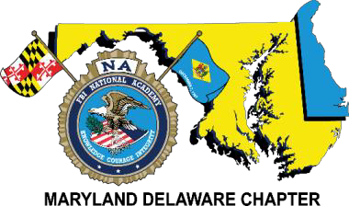
To our golf tournament supporters,

The Maryland/Delaware Chapter of the F.B.I. National Academy Associates is proud to announce that this year’s golf tournament will be held on Monday, September 14, 2020, at Mountain Branch Golf Course located at 1827 Mountain Road Joppa, Maryland 21085. The proceeds from the tournament will benefit the Maryland and Delaware Special Olympics, the Chapter’s scholarship fund and the F.B.I. Youth Leadership Program.
This annual tournament has generated funding for these charities, and we hope this year will be no exception.
Last year we raised over $7,000.00 which was divided between five college bound students, equal donations to Maryland’s and Delaware’s Special Olympic programs as well as funding the Chapter’s high school representative to attend the F.B.I.’s Youth Leadership Program in Quantico, Virginia.
Tournament participants are comprised of regional law enforcement leaders at the local, state, and federal levels. We also encourage our business partners and friends to participate by sponsoring or playing in the tournament to help us reach our fundraising goal. Each year we come together to raise money for these worthy charities, but we need your help.
We are seeking sponsorship and/or golfers for the tournament to maximize our fundraising efforts. Attached is a form noting the levels of sponsorship, but any donation amount can make a difference to these wonderful Special Olympic athletes, deserving scholarship and youth leadership recipients. Donations in the form of gifts for door prizes would also be a great contribution. Most importantly, you will be supporting very worthy causes.
Please take the time to review our sponsorship form and consider supporting the Chapter’s efforts. If you would like to join us for the event and enjoy a fun round of golf on an exclusive course, please consider registering to play. If you have any questions, please feel free to contact our golf tournament chairperson Joseph Conger
(josephconger@fbinaamdde.com) 443-895-0704 or Secretary/Treasurer Daniel Galbraith at (danielgalbraith@fbinaamdde.com) 410-808-8896.
We hope to have you as a partner this year!
Sincerely,
Joseph Conger
Joseph Conger
2020 Chapter President

MD/DE Chapter Secretary/Treasurer Dan Galbraith
2846 Bynum Overlook Drive Abingdon, Maryland 21009
danielgalbraith@fbinaamdde.com
410-808-8896
Visit our website at www.fbinaamdde.com

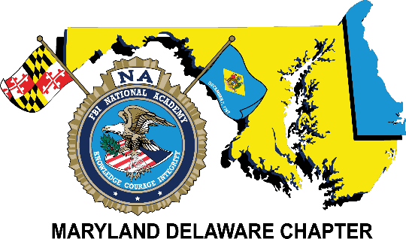
Benefiting:

The Maryland & Delaware Special Olympics,
the F.B.I.N.A.A., Inc. - MD/DE Chapter Scholarship & the F.B.I. Youth Leadership Program Fund
Monday, September 14, 2020
Mountain Branch Golf Course
1827 Mountain Road Joppa, Maryland 21085

SPONSORSHIP REGISTRATION
Professionally designed sign with your company name and logo

Silver | $100 | Program recognition
Gold | $250 | Silver recognition plus hole sign, & certificate of appreciation
Platinum/ Corporate | $500 | Gold recognition plus company logo displayed on Chapter website
Diamond/ Corporate | $1,000 | Platinum recognition plus company logo displayed on  tournament banner & two complimentary guests to play in the golf tournament

Company Name:
(Please print name as it should appear on sign and/or program)

Contact Name & Phone:

Payment Options
 | Credit Card Payment
 | Card Type: | MC VISA AMEX
 | Card #: | CVC: | EXP:
 | Check
 | Make checks payable to: FBINAA Maryland Delaware Chapter
Return form and payment to:
Daniel Galbraith, Chapter Secretary/Treasurer 2846 Bynum Overlook Drive, Abingdon, MD. 21009
E-mail Address: danielgalbraith@fbinaamdde.com
Telephone: 410-808-9986
For additional information regarding this tournament, please feel free to call:
Joseph Conger at 443-895-0704 or Daniel Galbraith at 410-808-8896.
FBINAA Maryland/Delaware Chapter Event: 2020 Golf Tournament

Please visit our website at www.fbinaamdde.com for more information

