2022 FBINAA Maryland/Delaware Chapter Event
Annual Golf Tournament
Monday, October 24, 2022

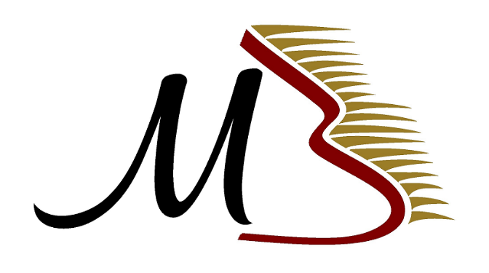
Mountain Branch Golf Course
1827 Mountain Road Joppa, Maryland 21085
Tournament benefits the Chapter Scholarship Fund,
Maryland/Delaware Special Olympics, and FBI Youth Leadership Program

Registration will begin @ 8:00 a.m. Shotgun Start @ 9:00 a.m.
Prizes / Longest Drive / Closest to the Pins

Lunch, beer, soda, and water are included throughout the day on the course.

COST
$150.00 per golfer

Limited to first 100 PAID Golfers
Entries must be submitted by October 16, 2022

2022 Golf Tournament Registration
Mountain Branch Golf Course

Organization Representing: _____________________________

Name | E-mail Address | Telephone Number

Make Checks Payable to: FBINAA Maryland/Delaware Chapter

Return this form with your check to:

Daniel Galbraith, FBINAA Secretary/Treasurer
2846 Bynum Overlook Drive, Abingdon, Maryland 21009

For additional information regarding this tournament, please feel free to call Dan at 410-808-8896 or email him at galbraithd@harfordsheriff.org

Return paid registration by October 16, 2022

Please visit our website at www.fbinaamdde.com for more information

