2023 FBINAA Maryland/Delaware Chapter Event
Annual Crab Feast
Fisherman’s Crab Deck
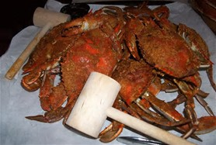
3116 Main Street
Grasonville, MD 21638
Friday, October 6th, 2023
Beginning At 11:00 a.m.
Name |  |  |  |  |  |  |  | Session #
Phone # |  |  |  | Cell # |  | E-mail
Mailing Address |  |  |  |  |  |  |  | Retired | Yes No
City/State/Zip
Agency
Event Cost: |  | $70.00/Person Includes All You Can Eat & Drink
Additional Guest(s):
 |  |  |  |  |  |  |  | Total Cost:$
Deadline To Register Is September 29th, 2023

Directions to Fisherman’s Crab Deck are found at www.fishermansinn.com

Payment by check preferred. Credit Card payment accepted.
Card Type: | MC VISA AMEX
Card #: | CVC: | EXP:
Make checks payable to: FBINAA Maryland Delaware Chapter

Return form and payment to:
Daniel Galbraith
Chapter Secretary/Treasurer
2846 Bynum Overlook Drive
Abingdon, Maryland 21009
Telephone: 410-808-8896 or E-mail: galbraithd@harfordsheriff.org

