2023 FBINAA Maryland/Delaware Chapter Event
Navy Tailgating
Navy-Marine Corp Memorial Stadium
Saturday, November 11th, 2023
Navy Midshipmen vs The University of Alabama
at Birmingham (UAB)
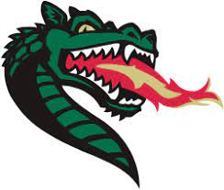
Tailgating begins at 12:00 p.m. with the game beginning at 3:30 p.m.
Game tickets will be distributed at the tailgate function.

Name |  |  |  |  |  |  |  | Session #
Phone # |  |  |  | Cell # |  | E-mail
Mailing Address |  |  |  |  |  |  |  | Retired | Yes ___ No ___
City/State/Zip
Agency
Event Cost: |  | $70.00/person includes tailgating (All you can eat and drink) and game ticket
Additional Guest(s):
 |  |  |  |  |  |  |  | Total Cost:$
Deadline To Purchase Tickets Is November 1st, 2023

Credit Card payment accepted. Payment by check preferred.
Card Type: | MC __ VISA __ AMEX __
Card #: | CVC: | EXP:
Make checks payable to: FBINAA Maryland Delaware Chapter
Return form and payment to:
Daniel Galbraith
Chapter Secretary/Treasurer
2846 Bynum Overlook Drive
Abingdon, Maryland 21009
Telephone: 410-808-8896 or E-mail galbraithd@harfordsheriff.org

